OAHPERD Benchmark Assessments

Greetings Colleagues,

The 2026 Benchmark Assessments are complete with OAHPERD branding as the result of HB 455, which eliminated the reporting of the assessment data to the State. The assessments have been developed by the writing teams who revised the Ohio PE State Standards, which passed Nov. 11, 2025, and align perfectly with the revised standards. The assessments were created for you to use and/or change to meet your teaching context. The assessments you will notice provide options and should help with your collection of data to support you student learning objectives. This data can be used to meet district and/or OTES requirements. Again, these are only recommended, not required. In receiving feedback from so many PE colleagues on how useful it has been to have the assessments ready for use, it was our (OAHPERD) duty to continue to provide you with high-quality assessments to match your high-quality Physical Education Program. As one PE Chair, wrote to me, “these assessments have become our gold standard and has helped to legitimize our content and programs. Without them I am nervous about our future”. So, please note these are not required by the state, but we hope you will use them, knowing you can change them to meet your needs.

Sincerely,

Mary La Vine – OAHPERD Past President
Traci Grissom, OAHPERD Education Chair
Entire PE Assessment writing teams
OAHPERD Physical Education Assessments
Standard  1 | Develops a variety of motor skills
Benchmark  B | Demonstrate developing control of fundamental manipulative skills.
Grade Band: K-2

1.K.6 | Bounces and catches a ball with both hands in a stable environment.
1.1.6 | Dribbles a ball with one hand in a stable environment through self and general space.
1.2.6 | Dribbles a ball with one hand using variations in speed, direction, pathway, and relationship with objects.
1.K.7 | Explores rolling a ball underhand.
1.1.7 | Rolls a ball underhand to a stationary target.
1.2.7 | Rolls a ball underhand to a stationary target at varying distances.
1.K.8 | Catches a bounced ball.
1.1.8 | Catches a self-tossed object with hands.
1.2.8 | Catches objects coming from different directions, heights, and speed.
1.K.9 | Explores throwing objects in a variety of ways.
1.1.9 | Throws objects using stepping in opposition.
1.2.9 | Performs an overhand throw while stepping in opposition, using a side orientation with variations in distance and force.
1.K.10 | Kicks a stationary ball.
1.1.10 | Kicks a ball for force using a backswing with the kicking leg and stepping next to the ball without hesitating or stopping before kick.
1.2.10 | Kicks a rolled or moving ball for power using critical elements.
1.K.11 | Explores dribbling an object with feet in self and general space.
1.1.11 | Dribbles an object with feet in self and general space.
1.2.11 | Dribbles a ball with feet using variations in speed, direction, pathway, and relationship with objects.
1.K.12 | Strikes a lightweight object (e.g., balloon) using different body parts and keeps it in the air.
1.1.12 | Strikes an object (e.g., ball, balloon) using different body parts.
1.2.12 | Strikes a variety of objects with hands to control force and direction.
1.K.13 | Explores striking a lightweight object (e.g., balloon) using a short- and long-handled implement (e.g., foam paddle).
1.1.13 | Strikes a lightweight object (e.g., balloon) using a short- and long-handled implement (e.g., foam paddle).
1.2.13 | Strikes an object using a short- and long-handled implement (e.g., foam paddle, pickleball paddle, tennis racquet) to control force and direction.
1.K.14 | Moves in time with a changing beat (e.g., music, drum, clap, stomp).
1.1.14 | Moves to a rhythmic beat or pattern.
1.2.14 | Performs rhythmic dance steps and sequences.
1.K.15 | Explores jumping over a rope.
1.1.15 | Jumps one time with a self-turned rope.
1.2.15 | Jumps continuously over a self-turned rope.

Task: All skills must be assessed and then combined to identify the student’s overall competency.

Skill and Task: Throwing (overhand) – Observe multiple repetitions of your students throwing overhand for force (“throw hard”), using a four- to six-inch ball toward a wall or large target.
Level | Throwing - Criteria
Advanced  3 | Able to throw a ball while consistently using a side orientation and stepping with opposition 70% of the time.
Proficient  2 | Able to throw a ball while stepping with opposition 50% of time.
Limited  1 | Has difficulty throwing a ball while stepping with opposition.

Skill and Task: Catching (with hands) – Observe multiple repetitions of your students catching an underhand throw (from a partner or a teacher). The ball should be four to six inches in diameter. Have the thrower vary the distance and height of the throw. Note: The quality of the throw will affect the ability to catch, so while students can throw to each other (if they are able), it might be necessary for the teacher to do some throwing, too.
Level | Catching - Criteria
Advanced  3 | Consistently catches a ball thrown from varying heights and locations (example: to the right, left, high, middle, low).
Proficient  2 | Consistently catches a ball using proper technique.
Limited  1 | Has difficulty and struggle to catch a ball using proper technique.

Skill and Task: Striking (with dominant hand) – Observe multiple repetitions of your students striking a stationary, light, soft ball (volleyball size) one-handed to a target area (about 10 feet wide).
Level | Striking - Criteria
Advanced  3 | Consistently strikes a ball with the dominant hand to a target area with good technique and accuracy.
Proficient  2 | Consistently strikes a ball with the dominant hand with good technique (reaches back, step with opposition, make contact level with the front knee, follow through to target).
Limited 1 | Has difficulty striking a ball with a hand with correct technique.

Skill and Task: Kicking – Observe multiple repetitions of your students kicking an age-appropriate moving ball to a target area (perhaps two cones about 15 feet apart). Ask your students to then roll the ball forward and kick it while it is still rolling at the target. Then have students kick from varying distances.
Level | Kicking - Criteria
Advanced  3 | Consistently kicks a moving ball to a target area with good technique and accuracy from varying distances.
Proficient  2 | Consistently kicks a moving ball to a target area from close range with good technique (moving in line with the ball, non-kicking foot close to the ball, kick through the center of the ball, follow through to the target).
Limited  1 | Has difficulty kicking a moving ball and demonstrates inaccuracy from close range.

Skill and Task: Dribbling – Observe multiple repetitions of your students dribbling with hands or feet in general space. Then ask them to speed up and slow down alternately and to change directions.
Level | Dribbling - Criteria
Advanced  3 | Able to dribble under control (and with correct form) with hands (one-handed) and feet at different speeds and while executing change in direction.
Proficient  2 | Able to dribble under control with hands or feet at different speeds (showing the ability to speed up and slow down when required).
Limited  1 | Has difficulty dribbling under control with hands and feet.

Score Rating:

Advanced | 15 – 13
Proficient | 12 – 10
Limited | 9 - below

OAHPERD Physical Education Assessments
Standard  2 | Applies knowledge related to movement and fitness concepts.
Benchmark  A | Understands and applies the knowledge of critical elements of fundamental motor skills and the principles of health-related fitness.
Grade Band: K-2

2.K.1 | Identifies boundaries for self-space and general space.
2.1.1 | Applies concepts of self and general space to accomplish movement tasks.
2.2.1 | Applies concepts of general and personal space to accomplish movement tasks in movement patterns, games, and tasks.
2.K.2 | Identifies differences in self and general space.
2.1.2 | Identifies the differences in levels and speed, along with self and general space, used within a physical education setting.
2.2.2 | Identifies the proper use of effort and distance, along with levels, speed, and space in a physical education setting.
2.K.3 | Distinguishes between locomotor skills and repeats the critical elements for each.
2.1.3 | Differentiates between locomotor and manipulative skills and identifies appropriate critical elements of each.
2.2.3 | Differentiates between locomotor, non-locomotor, and manipulative skills and identifies critical elements of each.
2.K.4 | Recognizes activities that contribute to fitness.
2.1.4 | Recognizes the difference between fitness components and activities (e.g. push-ups, sit-ups, running, jumping rope, etc.).
2.2.4 | Names activities that align with each component of health-related fitness (cardiorespiratory, muscular endurance, muscular strength, flexibility, and body composition).
2.K.5 | Repeats ways to stretch muscles in the body before physical activity.
2.1.5 | Identifies ways to stretch muscles in the upper and lower body before and after physical activity.
2.2.5 | Identifies ways to stretch muscles in various parts of the body before and after physical activity.
2.K.6 | Identifies water and cycling/wheeled safety skills and unique risks of each environment.
2.1.6 | Identifies water and cycling/wheeled safety skills and unique risks of each environment.
2.2.6 | Identifies water and cycling/wheeled safety skills and unique risks of each environment
Task: The students will show their understanding and application of the critical elements, fundamental motor skills, and principles of health-related fitness by completing the questions. The questions may be given orally, with pictures, or by selecting the correct answer on a test.
1. When hopping, you land on:
A. The same foot you started on
B. The other foot
C. Two feet
2. To run faster, you should:
A. Keep your arms still
B. Pump your arms
C. Put your arms above your head
3. What is the correct way to gallop?
A. One foot stays in front of the other
B. Your feet stay side by side
C. Your feet cross each other
4. When you are skipping, the pattern is:
A. Step, Hop, Step, Hop
B. Hop the whole time
C. Run and then jump
5. To jump high, you should:
A. Keep your legs straight
B. Keep your arms at your sides
C. Bend your knees and swing your arms

6. To keep your balance, you should:
A. Focus on a point and keep your weight centered
B. Wiggle your arms and legs
C. Look at the floor and lean back
7. To perform a forward roll, you should:
A. Keep you head up
B. Tuck your chin to your chest
C. Turn your head to the side
8. When throwing a ball overhand with your right hand, you should step with your:
A. Right foot
B. Left foot
C. You do not need to step
9. When swinging a bat or paddle, you should:
A. Keep your body still
B. Step front foot and rotate your body
C. Step with your back foot
10. When dribbling a basketball, you should look:
A. At the ball
B. At your feet
C. Where you are going

11. When rolling a ball, you should let go:
A. At a high level
B. At a low level
C. At a medium level
12. When kicking a soccer ball, your non-kicking foot should be:
A. Next to the ball
B. In front of the ball
C. Far away from the ball
13. When catching a ball near the ground, your fingers should point:
A. Forward
B. Up to the sky
C. Down to the ground
14. Before an overhand throw, your arm should be:
A. In an “L” shape behind your head
B. Straight out behind your head
C. Down by your side
15. To keep control while dribbling a soccer ball, you should:
A. Kick the ball far away
B. Tap the ball gently with your feet
C. Kick the ball high in the air

16. When catching a ball, you should keep your eyes on:
A. Your hands
B. Your feet
C. The ball
17. What foot do you step with when throwing overhand?
A. The same foot as your throwing hand
B. The opposite foot of your throwing hand
C. You do not need to step
18. When throwing or striking a ball following through helps the ball or object go?
A. Higher
B. Straighter and farther to the target
C. In a circle
19. After you throw a ball, your arm should:
A. Follow through toward the target
B. Point up to the sky
C. Stop as soon as you let go
20. When catching a ball at head height, your fingers should point:
A. Forward
B. Up to the sky
C. Down to the ground
Score Rating:
Advanced 3 | 20 - 15
Proficient 2 | 14 - 10
Limited 1 | 9 - below
OAHPERD Physical Education Assessments
Standard  2 | Applies knowledge related to movement and fitness concepts.
Benchmark  B | Understands and identifies the principles, components, and practices of health-related physical fitness.
Grade Band: K-2

2.K.7 | Recognizes the heart as a muscle that grows stronger with exercise and physical activity.
2.1.7 | Identifies the heart as a muscle that grows stronger with exercise and physical activity.
2.2.7 | Names activities that increase heart rate.
2.K.8 | Recognizes and differentiates between physical activity and inactivity.
2.1.8 | Identifies opportunities for physical activity.
2.2.8 | Identifies opportunities for physical activity as it relates to good health.
2.K.9 | Recognizes changes in the body during physical activity.
2.1.9 | Recognizes changes in the body during physical activity.
2.2.9 | Identifies physiological changes in the body during physical activity.
2.K.10 | Recognizes that food and hydration provide energy for physical activity.
2.1.10 | Differentiates between healthy and unhealthy food and beverage choices for physical activity.
2.2.10 | Suggests healthy alternatives to unhealthy food and beverage choices related to physical activity.

Task: The students will circle the correct answer.

- Circle the healthier option 2. Circle the healthier option

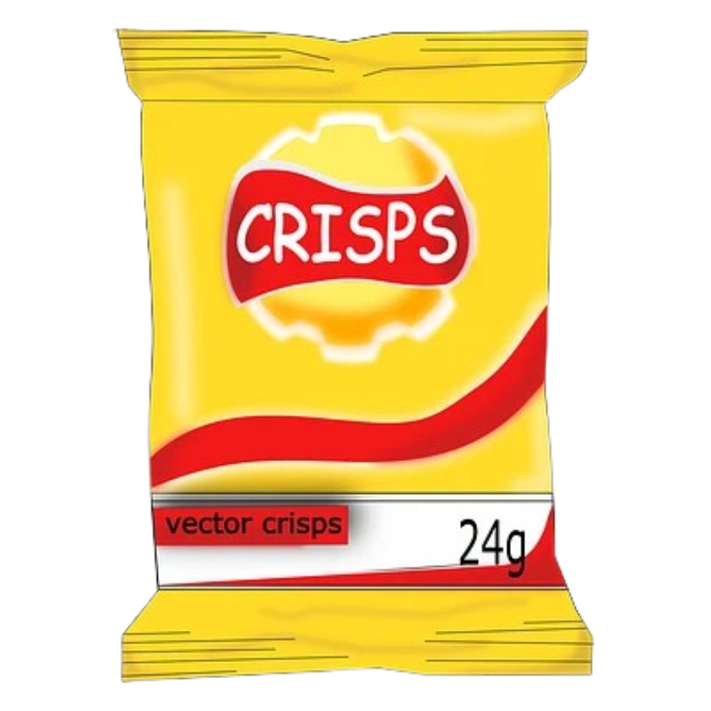
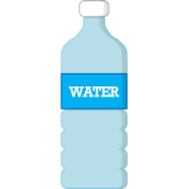


Soda Water Potato Chips Apple

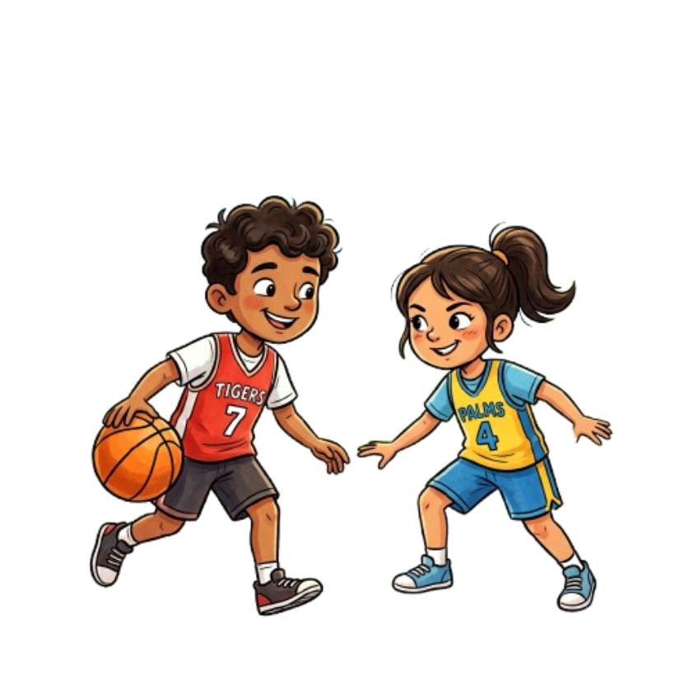
3. Circle the activity that makes your heart beat faster



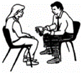

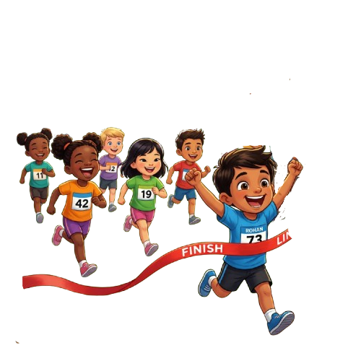
4. Circle the activity that makes your heart beat faster
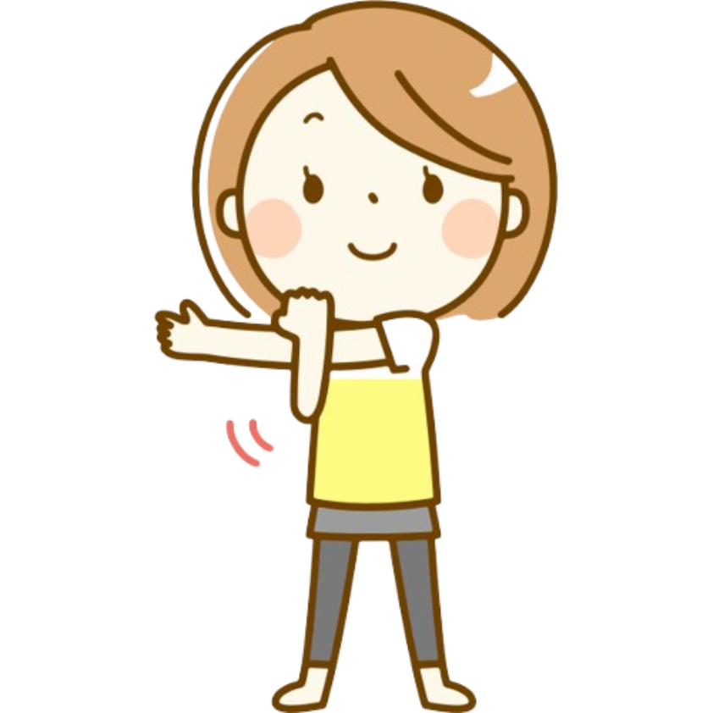
5. Circle the activity that makes your muscles stronger
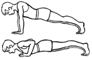


7. Circle the activity that stretches muscles in your upper body or arms

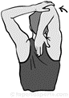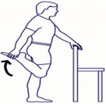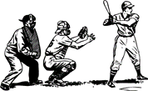

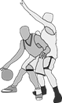
8. Circle the activity that stretches muscles in your legs

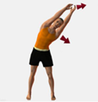

9. You should get at least ___________ minutes of physical activity per day. Circle the answer
100 60 30
10. Circle the group of pictures that shows how my body feels after working hard?
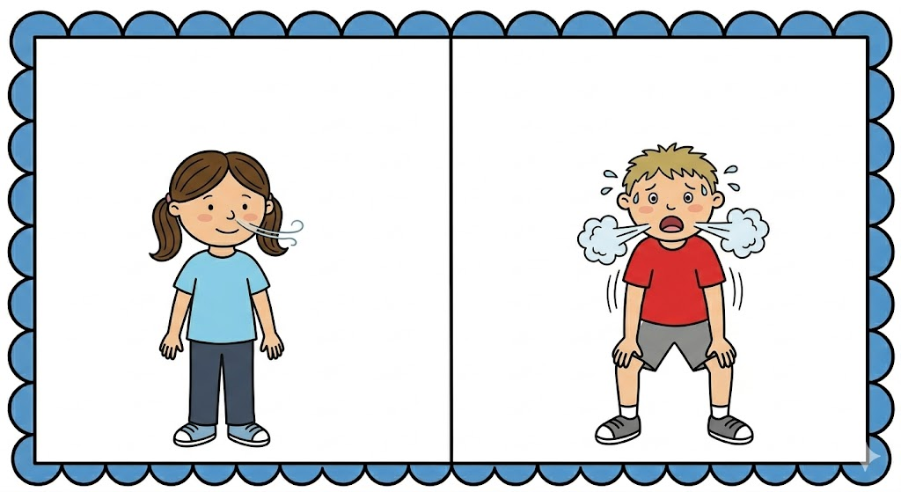
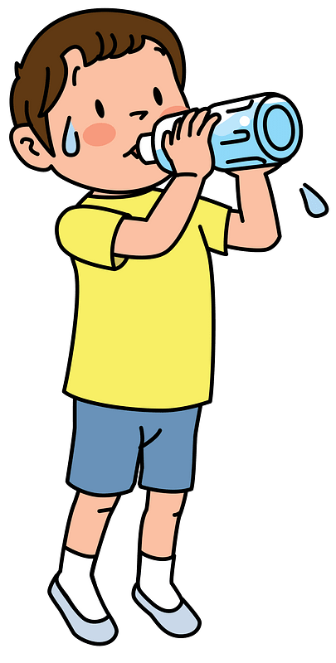
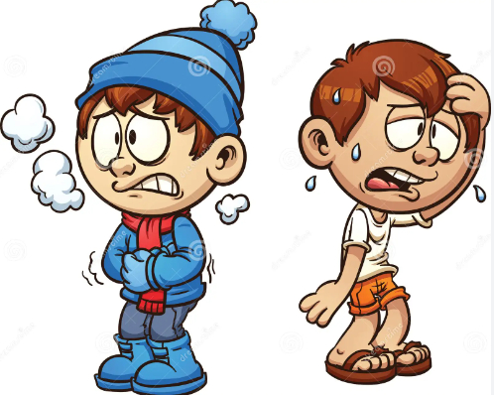


Cold, Not Thirsty, Breathing Easy Hot, Thirsty, Breathing Hard

Score Rating:
Advanced 3 | 10 - 8
Proficient 2 | 7 - 5
Limited 1 | 4 - below

 | OAHPERD Physical Education Assessment
Standard 4 | Develops personal skills, identifies personal benefits of movement, and chooses to engage in physical activity.
Benchmark A | Identifies health benefits as reasons to participate and values physical activity.
Benchmark B | Identifies personal benefits to participating in physical activity

 | Benchmark A
4.K.1 | Recognizes that physical activity has positive health benefits
4.1.1
4.2.1
4.K.2 | Recognizes that some physical activities are more challenging than some physical activities
4.1.2
4.2.2
4.K.3 | Explains that physical education class is an opportunity to being to physically active throughout the day
4.1.3
4.2.3
 | Benchmark B
4.K.4 | Identifies physical activities that are enjoyable based on personal interest
4.1.4
4.2.4
4.K.5 | Reflects on what activities are enjoyable during physical education class
4.1.5
4.2.5
4.K.6 | Follows short term physical activity goals provided by the teacher
4.1.6
4.2.6
4.K.7 | Practices strategies for managing one’s emotions and behaviors, such as breathing or sensory breaks during physical activity
4.1.7
4.2.7

Worksheet:
What are the health benefits of being physically active?
2
1


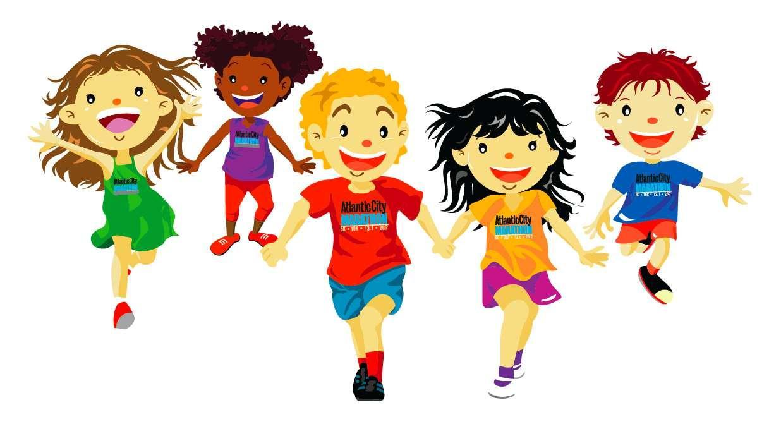

Being active gives me more energy! Being active makes my bones
& muscles stronger!
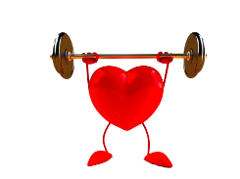
4

3

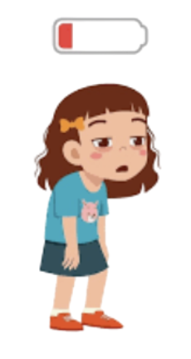

Being active helps my heart! Being active gives me less energy!
6

5

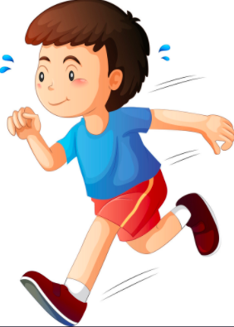
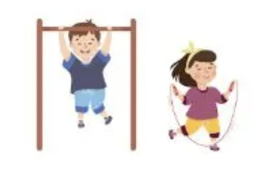

Being active helps me Being active makes me sweat!
move better!

Why would you enjoy being physically active?
1

2

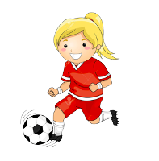


I like to improve my skills! I want to make new friends!
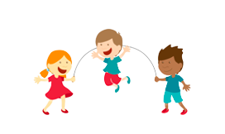
3 4

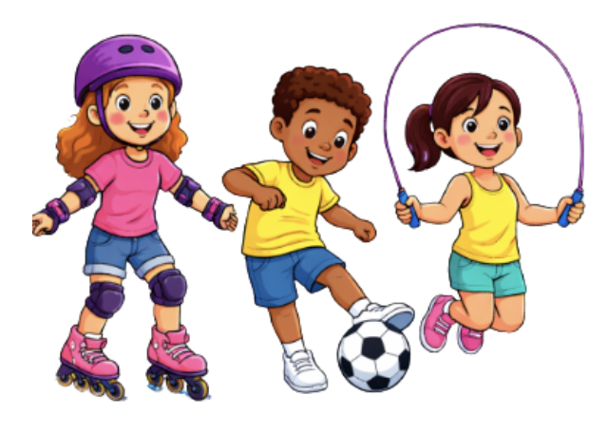

I like to play with friends! I get to try new things!
6

5

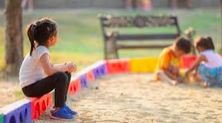
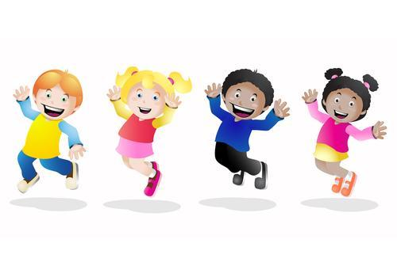

I like to have FUN! I like to play by myself!

How does physical education class help you to be active?
List your favorite activities from physical education class and why.

Task: Students must complete the worksheet that identifies specific health benefits from participation in daily physical activity. Students also will identify their personal reasons (why?) for enjoyment in an activity.

Level | Criteria
 | 4A  Identifies Health Benefits | 4B  Identifies Personal Reasons for Enjoyment
Advanced  3 | Identifies multiple health benefits of physical activity. | Identifies multiple reasons an individual would enjoy physical activity.
Proficient  2 | Identifies at least one health benefit of physical activity. | Identifies at least one reason to describe why an individual would enjoy physical activity.
Limited  1 | Does not identify the contribution of physical activity to good health. | Does not identify any reasons an individual would enjoy physical activity.

Score Rating

Advanced | 6-5
Proficient | 4-3
Limited | 2- below

 | OAHPERD Physical Education Assessments
Standard 1 | Develops a variety of motor skills.
Benchmark A | Demonstrates locomotor and non-locomotor skills in a variety of ways.

Grade Band K – 2
1.K.1 | Demonstrates the locomotor skills of walk and run using critical elements. Explores the locomotor skills of jump, gallop, slide, skip, hop, and leap in a stable environment.
1.1.1 | Demonstrates the locomotor skills of run, slide, and skip using critical elements. Explores locomotor skills (e.g., skip, run, gallop, slide, hop) while changing pathway, direction, or speed.
1.2.1 | Demonstrates all fundamental locomotor skills (walk, run, slide, gallop, hop, skip, jump, leap) while changing pathway, direction, or speed using critical elements.
1.K.2 | Explores jumping both vertically and horizontally, taking off on two feet and landing on two feet.
1.1.2 | Demonstrates jumping both vertically and horizontally, taking off on two feet and landing on two feet using critical elements.
1.2.2 | Performs jumping both vertically and horizontally, taking off on two feet and landing on two feet using critical elements.
1.K.3 | Explores transfer of weight by rocking and rolling.
1.1.3 | Demonstrates a variety of different rocking skills (e.g., forward/backward, side/side) and rolling skills (e.g., log, egg, parachute, circle, shoulder).
1.2.3 | Performs combinations of rolling and balance skills.
1.K.4 | Explores non-locomotor skills (e.g., bend, twist, turn, sway, stretch) in exploratory and stable environments.
1.1.4 | Demonstrates non-locomotor skills in exploratory and controlled settings and in response to verbal stimuli and non-verbal stimuli (e.g., mirroring or matching a partner).
1.2.4 | Performs combinations of non-locomotor and locomotor skills in a movement pattern.
1.K.5 | Explores balances using a variety of body parts (e.g., 1/2/3/4-point balances) and body shapes (e.g., wide, narrow, twisted).
1.1.5 | Demonstrates balances in a variety of ways using equipment (e.g., balance ball or board), apparatus (e.g., beam or box), or both.
1.2.5 | Performs static and dynamic balance skills as part of a movement pattern.
Task 1: Select at three skills for kindergarten and three skills for Grade 1 from the list below and identify the student’s level of competency. For Grade 2 all skills should be taught and data collected as Grade 2 should represent Mastery of the skills.

Skill and Task: Running – Observe multiple repetitions of your students running at a moderate speed (this could be done as a whole-class activity). Repeat the activity asking students to change speeds and pathways at times.

Level | Running - Criteria
Advanced  3 | Consistently demonstrates correct running (momentary free flight) technique with a smooth and effortless rhythm, at a variety of speeds and pathways.
Proficient  2 | Runs (momentary free flight) while demonstrating correct technique (head up, slight forward lean, heel-to-toe roll landing/push off, knee lift, rear-heel kick, bent arms and relaxed hands).
Limited  1 | Does not run or incorrect running technique (missing 5 or greater running cues).

Skill and Task: Skipping – Observe multiple repetitions of your students skipping around the gymnasium (this could be done as a whole-class activity).

Level | Skipping - Criteria
Advanced  3 | Consistently demonstrates correct skipping technique (head up, slight forward lean, step, hop action, and opposition arms and legs) with a smooth and effortless rhythm and at various speeds.
Proficient  2 | Consistently demonstrates correct skipping technique (head up, slight forward lean, step, hop action, and opposition arms and legs) with a smooth and effortless rhythm.
Limited  1 | Does not skip or incorrect skipping technique (head up, slight forward lean, step, hop action, and opposition arms and legs).

Skill and Task: Gallop – Observe multiple repetitions of your students galloping at a moderate speed (this could be done as a whole-class activity). Have students try to gallop with both their right and left legs as the lead leg. Repeat the activity asking students to change speeds and pathways at times.

Level | Galloping - Criteria
Advanced  3 | Consistently demonstrates correct galloping technique with a smooth and effortless rhythm, at a variety of speeds and pathways with both the right and left legs as the lead leg.
Proficient  2 | Gallops while demonstrating correct technique (head up, forward movement/body orientation, pushes off the toes, arms bent, low-flight pattern, legs do not cross over).
Limited  1 | Does not perform galloping or incorrect galloping technique (missing 4 or more cues).

Skill and Task: Slide – Observe multiple repetitions of your students sliding at a moderate speed (this could be done as a whole-class activity). Have students try to slide with both their right and left legs as the lead leg. Repeat the activity asking students to change speeds and pathways at times.
Level | Sliding - Criteria
Advanced  3 | Consistently demonstrates correct sliding technique with a smooth and effortless rhythm, at a variety of speeds and pathways with both the right and left legs as the lead leg.
Proficient  2 | Slides while demonstrating correct technique (head up, sideways movement/body orientations, pushes off the toes, arms bent, low-flight pattern, legs do not cross over).
Limited  1 | Does not perform sliding or incorrect sliding technique (missing 4 or more cues).

Skill and Task: Hopping - Observe multiple repetitions of your students hopping on one leg on their preferred legs (this could be done as a whole-class activity). Following this, assess students hopping on non-preferred legs (this can be done with just those that have mastery of preferred leg or whole class).

Level | Hopping - Criteria
Advanced  3 | Consistently demonstrates correct (one-leg) hopping technique while moving forward on both right and left legs.
Proficient  2 | Hops on the preferred leg with correct technique (head up, slight forward lean, knee bent to absorb the landing, pendulum action of the non-supporting leg, use of arms to aid momentum).
Limited  1 | Does not perform hopping or incorrect hopping technique on the preferred leg (missing 3 or more cues).

Skill and Task: Jumping - Observe multiple repetitions of your students jumping vertically (this could be done as a whole-class activity). After a few moments, tell the students to switch to a horizontal jump.

Level | Jumping - Criteria
Advanced  3 | Consistently demonstrates correct jumping technique both vertically and horizontally.
Proficient  2 | Jumps either vertically or horizontally while demonstrating the correct technique (head up, slight forward lean, knees bent, takes off using arms to aid momentum up or forward and lands on two feet simultaneously,).
Limited  1 | Does not perform a jump or incorrect jumping technique (missing 3 or more).

Task 2: Pick two from the three listed below and assess the students on each skill to identify the student’s level of competency. For Grade 2 skills should be taught and data collected as Grade 2 should represent Mastery of the skills.

Skill and Task: Rolling – Observe multiple repetitions of your students attempting simple rolls (e.g., log, egg, parachute, circle, shoulder) on mats or other appropriate and safe surfaces.
Skill and Task: Balance – Observe multiple repetitions of your students holding different (1-, 2-, 3-, 4-point) balances. Then ask students to combine balances with limb extensions, raising the center of gravity, and/or narrow-base supports.
Skill and Task: Rhythm – Observe your students engaged in rhythmic activity, moving in time to a beat and combining steps together with good rhythm. Activities could include moving with a drum beat, jump rope, Chicken Dance, Hokey Pokey or other simple dances.

Level | Rolling - Criteria | Balance - Criteria | Rhythm - Criteria
Advanced  3 | Rolls are performed with smooth and effortless technique. | Able to hold 1-, 2-, 3-, and 4-point balances with good technique and holds each balance position while either: extending a limb, center of gravity points are raised, and/or a narrower base of support is achieved for five seconds or more. | Demonstrates good rhythm by performing a varied sequence or following/showing multiple movements in time with music.
Proficient  2 | Students perform individual rolls with good technique (maintains body shape with tight muscles [curved, straight or round], body alignment and fluid motion). Rolls are smooth, some body parts may be loose. | Able to hold 1-, 2-, 3-, and 4-point balances with good technique (maintains body shape with tight muscles, body alignment, held for three seconds). | Able to move in time to a beat.
Limited  1 | Students cannot roll or use incorrect rolling technique (missing 3 or more cues). Rolls are choppy; all body parts are “loose.” | Balances (1-, 2-, 3-, and 4-point) have limited alignment and are unsteady (not held for three seconds). | Cannot move in time to a beat.
OAHPERD Physical Education Assessment
Standard 3 | Develops social skills through movement
Benchmark A | Knows and follows procedures and safe practices
Benchmark B | Engages in responsible behavior in physical activity settings

 | Benchmark A
3.K.1 | Explains why rules related to safety are important.
3.1.1 | Explains why rules related to safety are important for self and others.
3.2.1 | Describes why following rules are important for safety and fairness.
3.K.2 | Follows directions and uses equipment safely with a partner.
3.1.2 | Follows directions and uses equipment safely with a partner or within a group.
3.2.2 | Follows directions and uses equipment safely with a partner and within a group.
 | Benchmark B
3.K.3 | Recognizes that others have feelings.
3.1.3 | Recognizes that others have feelings different from one’s own.
3.2.3 | Respects feelings of those who may be of different backgrounds or different skill levels.
3.K.4 | Claps and cheers for classmates.
3.1.4 | Provides frequent positive comments or gestures to classmates.
3.2.4 | Provides frequent positive comments or gestures to classmates who are being challenged.
3.K.5 | Listens to and uses kinds words in a physical activity setting.
3.1.5 | Listens to and uses kind words while working with a partner.
3.2.5 | Communicates positively in small group physical activities.
3.K.6 | Respond appropriately to directions and feedback from the teacher.
3.1.6 | Responds appropriately to directions and feedback from the teacher.
3.2.6 | Responds appropriately to directions and feedback from the teacher.
3.K.7 | Engages in positive behaviors that are respectful to others.
3.1.7 | Engages in positive behaviors that are respectful to others independently or with a partner.
3.2.7 | Engages in positive behaviors that are respectful to others in small group settings.
3.K.8 | Recognizes problems in a physical activity setting and asks for support from a teacher.
3.1.8 | Describes a problem in a physical activity setting and asks for support from a teacher.
3.2.8 | Communicates a problem and offers solutions to a partner or small group in a physical activity setting, with teacher support.
3.K.9 | Engages in behaviors that are helpful to others as directed by the teacher (e.g. taking turns, using equipment, and interacting positively with others).
3.1.9 | Engages in behaviors that are helpful to others as directed by the teacher (e.g., taking turns, using equipment, and interacting positively with others).
3.2.9 | Engages in behaviors that are helpful to others as directed by the teacher (e.g., taking turns, using equipment, and interacting positively with others).
3.K.10 | Identifies physical activities that foster global awareness and build community
3.1.10 | Identifies physical activities that foster global awareness and build community.
3.2.10 | Identifies physical activities that foster global awareness and build community.

Task: Observe students in physical activity setting displaying social skills.

Criteria | Advanced (3) | Proficient (2) | Limited (1)
Safety & Equipment use | Consistently follows all rules and uses equipment safely without being reminded. | Follows safety rules and uses equipment safely with occasional reminders. | Often needs reminders to use equipment appropriately to stay safe or follow class rules.
Cooperation &  Fair Play | Proactively shares equipment, takes turns, and works well with any partner. | Shares equipment and takes turns when asked by the teacher. | Struggles to share equipment or take turns with others.
Respect for Others & Accept feedback | Consistently uses kind words; actively recognizes and respects that others have feelings, and accepts feedback. | Sometimes uses positive words;  respects others', accepts feedback, and recognizes other feelings. | Rarely uses kind words, respects others', accepts feedback, and recognizes other feelings.
Global awareness and community | Consistently recognizes that others are different and appreciate the difference they bring to class. | Sometimes recognizes that others are different and appreciate the difference they bring to class. | Rarely recognizes that others are different and appreciate the difference they bring to class.

Score Rating:
Advanced | 12-10
Proficient | 9-6
Limited | 5 - below

